# Door Power Lock

**System Functional Specification**

**Project ： T26**

**Version ： V06**

**Edit ：**

**Review ：**

**Approved ：   
Data ：**

# Object and Reference

The purpose of the specification is to provide reference of developing a Door Control Module system. We call this system T26 DCM.

**Reference:**

|  |  |  |  |  |
| --- | --- | --- | --- | --- |
| **Date** | **Version** | **Description** | **Page** | **Edit** |
| 2021.08.24 | V01 | Initial Draft | / | DuJiawei |
| 2021.09.02 | V02 | Updata Centre Lock&Child Lock Control  Updata  vehicle model | / | DuJiawei |
| 2021.09.23 | V03 | Add ChildInhibitSts [signal](javascript:;) and DCM receive it | / | DuJiawei |
| 2021.09.26 | V04 | Delete DoorOpenFailSts [Signal](javascript:;) | / | DuJiawei |
| 2021.11.05 | V05 | Updata Power [Release](javascript:;) PWM | / | DuJiawei |
| 2022.07.27 | V06 | Updata Power [Release](javascript:;) PWM AND Electric Release Process Functional Requirement | / | Huqun |

2．Electrical & Environmental Specifications

## 2.1 Operating temperature

Operation temperature range: - 40℃ to 85℃

Storage temperature range: -40ºC ~ 90ºC

|  |  |  |  |
| --- | --- | --- | --- |
| Number | Item | Min(℃) | Max(℃) |
| 1 | Operating Temperature | -40 | 85 |
| 2 | Storage Temperature | -40 | 90 |

## 2.2 Operating Voltage range

|  |  |  |  |  |
| --- | --- | --- | --- | --- |
| Number | Item | Description | Min(V) | Max(V) |
| 1 | all local function | Normal Operating Voltage | 9.0 | 16 |
| 2 | CAN | Normal Operating Voltage | 6.0 | 18 |
| 3 | LIN | Normal Operating Voltage | 6.0 | 18 |

**2.3 Quiescent Current：**

The quiescent current is defined as: I≤0.8mA.

# 3 Electric Block Diagram



# 4 Function detail

## 4.1 Door Power Releasing Management

**4.1.1 Working Conditions**

|  |  |  |  |  |
| --- | --- | --- | --- | --- |
| Working Conditions | Functionality | Network Wake UP | Wake Up Source | Remark |
| Ignition Off(+30) | Electric releasing  Releasing Reset |  |  |  |
| Ignition Acc(+15) | Electric releasing  Releasing Reset |  |  |  |
| Ignition On(+15) | Electric releasing  Releasing Reset |  |  |  |
| Timed with ignition off |  |  |  |  |
| Cut off during starting |  |  |  |  |
| Cut off with low battery |  |  |  |  |

**4.1.2 Function Diagram**

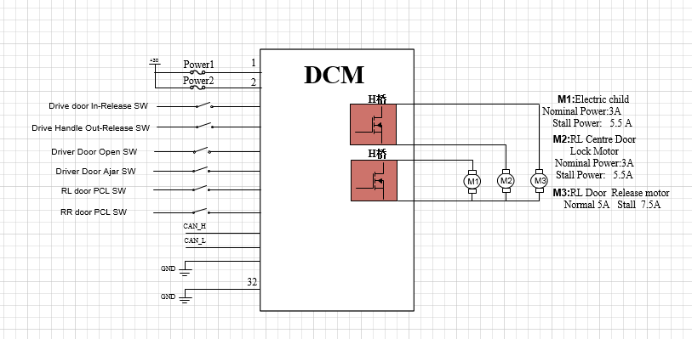

**4.1.3 I/O information**

Input list:

|  |  |  |  |  |  |
| --- | --- | --- | --- | --- | --- |
| Signal | Signal types | High/Low active | Owner | Receiver | Remark |
| Drive door In-Release SW | Digital | Low active | SW | DCM |  |
| Psng door In-Release SW | Digital | Low active | SW | DCM |  |
| RL door In-Release SW | Digital | Low active | SW | DCM |  |
| RR door In-Release SW | Digital | Low active | SW | DCM |  |
| Driver Handle Out-Release SW | Digital | Low active | SW | DCM |  |
| Psng Handle Out-Release SW | Digital | Low active | SW | DCM |  |
| RL Handle Out-Release SW | Digital | Low active | SW | DCM |  |
| RR Handle Out-Release SW | Digital | Low active | SW | DCM |  |
| Driver Door Open SW | Digital | Low active | SW | DCM |  |
| Psng door Open SW | Digital | Low active | SW | DCM |  |
| RL door Open SW | Digital | Low active | SW | DCM |  |
| RR door Open SW | Digital | Low active | SW | DCM |  |
| Driver Door Ajar SW | Digital | Low active | SW | DCM |  |
| Psng door Ajar SW | Digital | Low active | SW | DCM |  |
| RL door Ajar SW | Digital | Low active | SW | DCM |  |
| RR door Ajar SW | Digital | Low active | SW | DCM |  |

Output list:

|  |  |  |  |
| --- | --- | --- | --- |
| Signal | Drive types | High/Low drive | Remark |
| Drive Door Release motor | 继电器+MOS | High side |  |
| Drive Door motor Release Resetting | 继电器+MOS | High side |  |
| Psng Door Release motor | 继电器+MOS | High side |  |
| Psng Door Release motor Resetting | 继电器+MOS | High side |  |
| RL Door Release motor | 继电器+MOS | High side |  |
| RL Door Release motor Resetting | 继电器+MOS | High side |  |
| RR Door Release motor | 继电器+MOS | High side |  |
| RR Door Release motor Resetting | 继电器+MOS | High side |  |

CAN message list:

|  |  |  |  |  |  |  |
| --- | --- | --- | --- | --- | --- | --- |
| Signal | Bit Size | Property | Value | Owner | Receiver | Remark |
| DriverDoorLockSts | 1 | Lock  Unlock | 0x0  0x1 | BDM | DCM |  |
| SlaveVehMod | 3 | Factory  Transport Normal   Dyno   Crash Factory Paused  Transport Paused Reserved | 0x0  0x1  0x2  0x3  0x4  0x5  0x6  0x7 | BDM | DCM |  |
| DriverDoorSts | 1 | Close  Open | 0  1 | DCM | BDM |  |
| PsngrDoorSts | 1 | Close  Open | 0  1 | DCM | BDM |  |
| LHRdoorSts | 1 | Close  Open | 0  1 | DCM | BDM |  |
| RHRDoorSts | 1 | Close  Open | 0  1 | DCM | BDM |  |
| VehPwrMod | 3 | OFF  ACC  ON  Crank  Running  Reserved | 000  001  010  011  100  Others | BDM | DCM |  |
| CrashOutputSts | 8 | No Crash  Belt Crash  Front Crash  Left Side Crash  Right Side Crash  Rear Crash | 0x0  0x1  0x2  0x4  0x8  0x10 | ABM | DCM |  |
| VehicleSpeedVSOSig | 13 | Accuracy  Range high  Range low  Conversion  Unit  Startup  Invalid | 0.0625 km/h  511.875 km/h  0 km/h  (D)/ 16  km/h  0 km/h  1FFF | ESP | DCM |  |
| WindowInhibitSts | 1 | Permit  Inhibit | 0x0  0x1 | BDM | DCM |  |
| ChildInhibitSts | 1 | LOCK  UNLOCK | 0x0  0x1 | BDM | DCM |  |
| ChildSafetySts | 3 | Not Used  Unlock  Lock Failure | 0x0  0x1  0x2  0x3 | BDM | DCM |  |
| PwrDoorErr  电动释放门故障 | 1 | Normal  Error | 0x0  0x1 | DCM | ICM |  |
|  |  |  |  |  |  |  |

**4.1.4 Electric Release Process**注：此流程下需按15KHz的频率调试门锁电机，达到占空比的需求  
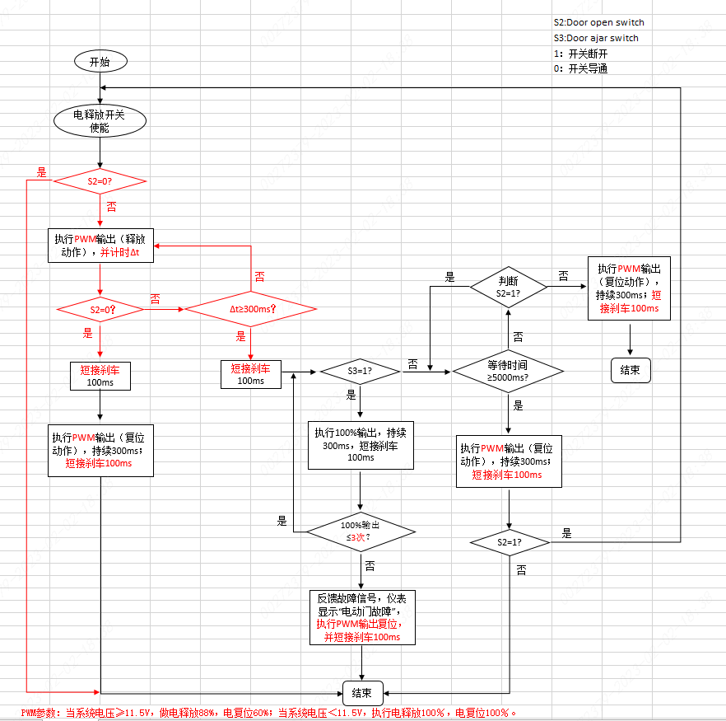

**4.1.5 Functional Requirement**

**4.1.5.1解锁状态下，触发外部/内部电释放微动开关、实现电动释放**

**前置条件：**( 1&2&3& )

1. 电源模式：OFF、ACC、ON、Crank、Running档；
2. 接收到BDM发出的Unlock状态信号；
3. 对应车门Open信号处于门关闭状态；

**触发条件：**(1)

1、任意车门外部/内部电释放微动开关信号跳变（从断开变为吸合）

**执行驱动输出：**( 1&2 )

1、执行对应车门电动释放；

2、DCM实时发送车门状态信号**XxDoorSts**及半锁信号**XxDoorOpenSts**；

**停止驱动条件：**( 1 | 2 )

1、对应车门Open&Ajar信号处于门开启状态（0x0：关闭、0x1：开启）；

2、电释放时间＞300ms具体数据待标定；

**4.1.5.2闭锁状态下，禁止外部微动开关、屏蔽电动释放**

**前置条件：**( 1&2 )

1. 电源模式：OFF、ACC、ON、Crank、Running档；

**触发条件：**（1）

1. 接收到BDM发出的LOCK状态信号：DriverDoorLockSts=0x0；

**执行驱动输出：**( 1 )

1、屏蔽外部微动开关信号输入；

**4.1.5.3闭锁状态下，触发内部微动开关，执行整车解锁，激活电动释放**

**前置条件：**( 1&2&3&4 )

1. 电源模式：OFF、ACC、ON、Crank、Running档；
2. BDM发出的中控锁状态为闭锁状态：；
3. 车速＜5km/h；

**触发条件：**( 1 )

1、触发两次内部电释放开关；

**执行驱动输出：**( 1|2 )

1. 主驾门按一次执行整车中控解锁，再按一次执行主驾门电释放；
2. 除主驾外其它门按完第一次开始计时2S（此时不解整车中控，2S内按下第2次，执行对应车门电释放，同时解对应车门门锁；若超过2S按下第2次，则重新开始计时；）

**4.1.5.4接收到整车碰撞信号，激活电动释放**

**前置条件：**(（1|2）&3 &4)

1. 电源模式：非OFF档；
2. 电源档位从ON档变化到OFF档的1S内；
3. 收到气囊发出的碰撞状态信号或硬线信号：CrashOutputSts≠0x00；

**触发条件：**（1）

1. 接收到碰撞信号6S后， 检测电动释放开关使能(6s后，才开始检测电释放开关使能)；（6s内屏蔽电动释放功能，6s后解除屏蔽电动释放功能）。

**执行驱动输出：**( 1 )

1、激活电动释放开关使能，此时触发微动开关，激活电动释放；

**4.1.5.5接收到儿保锁上锁反馈信号，屏蔽电动释放**

**前置条件：**( 1&2&3 )

1、电源模式：OFF、ACC、ON、Crank、Running档；

1. 后门儿保锁上锁；

**触发条件：（** 1 **）**

1. 接收到儿保锁上锁反馈信号：
2. ChildSafetySts==0x2：Lock；
3. **执行驱动输出：**( 1 )

1、屏蔽后侧内部车门电释放功能；

**4.1.5.6接收到车速信号，屏蔽电动释放**

**前置条件：**( 1&2 )

1、电源模式：ON、CRANK、Running；

2、车辆模式；运输模式除外；

**触发条件：（**1**）**

1、车速≥5 Km/h；

**执行驱动输出：**( 1 )

1. 屏蔽内外电释放开关使能信号；

**4.1.5.7异常场景**

电动释放功能主要有以下异常处理策略：

卡住（堵转）：①电动释放过程中，若一段时间300ms（具体数据标定）未检测到Ajar&Open信号跳变，则执行场景②的逻辑：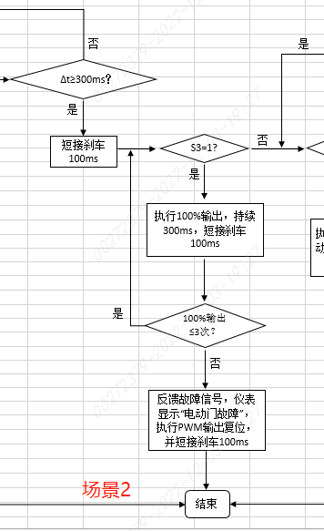

最多执行全输出三次，若始终无跳变，则DCM通过CAN总线反馈错误信息（PwrDoorErr ==0x1：Error），仪表显示当前错误“电开门故障”并执行复位例程；

②DCM检测到Ajar信号发生跳变，执行场景③的逻辑：

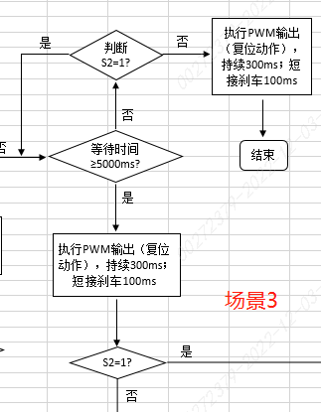

电动释放门锁进入雪载模式，等待5S； 5S时间内, 检测到Door Open信号发生跳变， DCM直接执行复位动作，完成电动释放，5S后, DCM直接驱动电动释放门锁复位，复位后再次判断Door Open信号，若仍未跳变，则进入场景1流程：

**备注：**电动释放功能发生故障后，电动释放功能重新完成一个周期，则认为当前故障消失；

1. 整车断电后重新上30电，DCM执行电释放电机复位一次；
2. 优先级定义：

1、电释放和电复位，作为一个整体动作，不可拆分  
2、当执行电释放功能时，不响应儿童保护功能，不响应解闭锁功能。

3、当电动释放功能输入和儿童保护功能输入、解闭锁功能输入同时有效时，优先执行电动释放功能。

4、电释放儿保锁功能、解闭锁功能。不允许互相打断。

即：当前的动作正在执行时，不响应其他复用的功能请求。

## 4.2 Door Centre Lock Management

**4.2.1 Working Conditions**

|  |  |  |  |  |
| --- | --- | --- | --- | --- |
| Working Conditions | Functionality | Network Wake UP | Wake Up Source | Remark |
| Ignition Off(+30) | Centre Lock Control |  |  |  |
| Ignition Acc(+15) | Centre Lock Control |  |  |  |
| Ignition On(+15) | Centre Lock Control |  |  |  |
| Timed with ignition off |  |  |  |  |
| Cut off during starting |  |  |  |  |
| Cut off with low battery |  |  |  |  |

**4.2.2 Function Diagram**



**4.2.3 I/O information**

Input list:

|  |  |  |  |  |  |
| --- | --- | --- | --- | --- | --- |
| Signal | Signal types | High/Low active | Owner | Receiver | Remark |
| / | / | / | / | / |  |

Output list:

|  |  |  |  |
| --- | --- | --- | --- |
| Signal | Drive types | High/Low drive | Remark |
| Drive Door Centre Lock | MOS | High side |  |
| Psng Door Centre Lock | MOS | High side |  |
| RL Door Centre Lock | MOS | High side |  |
| RR Door Centre Lock | MOS | High side |  |

CAN message list:

|  |  |  |  |  |  |  |
| --- | --- | --- | --- | --- | --- | --- |
| Signal | Bit Size | Property | Value | Owner | Receiver | Remark |
| DriverDoorLockSts | 1 | Lock  Unlock | 0x0  0x1 | BDM | DCM |  |
| DoorLockCMD | 3 | default  Driver unlock action  Passenger unlock action  all door unlock action  all door lock action  Reserved | 0x0  0x1  0x2  0x3  0x4  0x5-0x7 | BDM | DCM |  |
| CrashOutputSts | 8 | No Crash  Belt Crash  Front Crash  Left Side Crash  Right Side Crash  Rear Crash | 0x0  0x1  0x2  0x4  0x8  0x10 | ABM | DCM |  |
| VehPwrMod | 3 | OFF  ACC  ON  Crank  Running  Reserved | 000  001  010  011  100  Others | BDM | DCM |  |

* + 1. **Functional Requirement**

**4.2.4.1闭锁功能**

**前置条件：**( 1 )

1. 电源模式：OFF、ACC、ON、Crank、Running；

**触发条件：**（1）

1. DCM收到BDM发送的闭锁命令：DoorLockCMD==0x4；

**执行驱动输出：**( 1 )

1. DCM输出200ms±50ms驱动门锁电机，执行四门闭锁；

**4.2.4.2 解锁功能**

**前置条件：**( 1 ~~|~~ 2 )

1. 电源模式：OFF、ACC、ON、Crank、Running；

**触发条件：（**1 | 2 | 3 **）**

1. DCM收到BDM发送的解锁命令：DoorLockCMD==0x1；
2. DCM收到BDM发送的解锁命令：DoorLockCMD==0x2；
3. DCM收到BDM发送的解锁命令：DoorLockCMD==0x3；

**执行驱动输出：**( 1 | 2 | 3 )

1. DCM输出200ms±50ms驱动门锁电机，执行主驾门解锁输出；
2. DCM输出200ms±50ms驱动门锁电机，执行除主驾门外其余门解锁输出；
3. DCM输出200ms±50ms驱动门锁电机，执行主驾门+其余门解锁输出；

**4.2.4.3碰撞解锁**

**前置条件：**( 1 | 2 )

1. 电源模式: ON、Crank、Running；
2. 点火开关由ON切换到OFF档1s内；

**触发条件：（**1**）**

1. DCM收到有效CAN碰撞信号CrashOutputSts从0跳转到非0状态 || 有效硬线碰撞信号；

**执行驱动输出：**( 1 )

1. DCM立即驱动门锁电机执行两次解锁动作：主驾门解锁输出和乘客门解锁输出同时有效200ms，等待100ms后，儿保锁解锁输出200ms，等待100ms，此为一次碰撞解锁动作。等待400ms，再执行一次碰撞解锁动作；

## 4.3 Electric Child Lock Management

**4.3.1 Working Conditions**

|  |  |  |  |  |
| --- | --- | --- | --- | --- |
| Working Conditions | Functionality | Network Wake UP | Wake Up Source | Remark |
| Ignition Off(+30) | Electric Child Lock Control |  |  |  |
| Ignition Acc(+15) | Electric Child Lock Control |  |  |  |
| Ignition On(+15) | Electric Child Lock Control |  |  |  |
| Timed with ignition off |  |  |  |  |
| Cut off during starting |  |  |  |  |
| Cut off with low battery |  |  |  |  |

**4.3.2 Function Diagram**



**4.3.3 I/O information**

Input list:

|  |  |  |  |  |  |
| --- | --- | --- | --- | --- | --- |
| Signal | Signal types | High/Low active | Owner | Receiver | Remark |
| RL door PCL SW | Digital | Low active | DCM |  |  |
| RR door PCL SW | Digital | Low active | DCM |  |  |

Output list:

|  |  |  |  |
| --- | --- | --- | --- |
| Signal | Drive types | High/Low drive | Remark |
| RL Electric Child Lock | MOS | High side |  |
| RR Electric Child Lock | MOS | High side |  |

CAN message list:

|  |  |  |  |  |  |  |
| --- | --- | --- | --- | --- | --- | --- |
| Signal | Bit Size | Property | Value | Owner | Receiver | Remark |
| WindowInhibitSts | 1 | Permit  Inhibit | 0x0  0x1 | BDM | DCM |  |
| ChildInhibitSts | 1 | LOCK  UNLOCK | 0x0  0x1 | BDM | DCM |  |
| ChildSafetySts | 3 | Not Used  Unlock  Lock Failure | 0x0  0x1  0x2  0x3 | BDM | DCM |  |

**4.3.4Functional Requirement**

**4.3.4.1儿保锁闭锁功能**

**前置条件：**( 1 )

1. 电子儿童安全锁配置字为0x1:Present ；

**触发条件：**（1）

1. DCM收到BDM发送的儿保锁闭锁命令：WindowInhibitSts==0x1|| ChildInhibitSts==0x0；

**执行驱动输出：**( 1 )

1. 执行儿保锁闭锁输出200ms；

**4.3.4.2儿保锁解锁功能**

**前置条件：**( 1 )

1. 电子儿童安全锁配置字为0x1:Present ；

**触发条件：**（1）

1. DCM收到BDM发送的儿保锁解锁命令：WindowInhibitSts==0x0|| ChildInhibitSts==0x1；

**执行驱动输出：**( 1 )

1. 执行儿保锁解锁输出200ms；

